Version

1

Braille Simulation Software

User Manual

Getting Started

Chapter

1

Usage Guidelines

t

his software was made as an educational tool for visually impaired students. By emulating the behavior of braille cells, this software allows for the creation of interactive ‘scenarios.’ These scenarios are driven by the actions of the students via a braille interface. The usage of interactive scenarios in education allows for students to read and learn the language of braille in a fun and involved setting. Educators are encouraged to create their own custom scenarios with this software, the process of which is detailed throughout this manual. The robust scenario creation platform ensures you will be able to make highly functional and customized scenarios for your students. The scenario authoring software creates scenarios which can be interfaced with braille supporting hardware like Treasure Box Braille.

# Installation Instructions

The software can be downloaded from [ TBD ]. After it has been downloaded, double click the JAR file and you will immediately be presented with the main menu screen. From here, you may begin to use the software.

# Scenarios

###### Factory Scenarios This software includes three basic factory created scenarios for you to test out yourself.

Scenarios are the focus of this software. They serve as the tools one can use to interact with the braille device simulator or TBB hardware. Scenarios are interactive sequences of events that can be interacted with. A scenario can be created with our authoring app, which supports:

1. Decision making in braille that drives the scenario forward
2. Audio recording playback to speak to the user in the scenario

# Playing a Scenario

Scenarios can be tested and played inside the software using the TBB hardware simulator. It is easily accessible from the Main Menu. Select “Play a Scenario.”

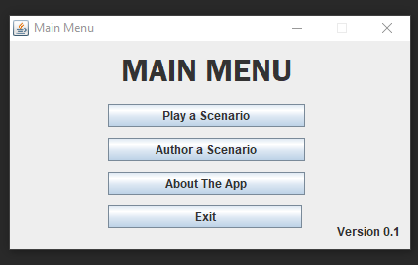

From here, you will be prompted to select a scenario file:

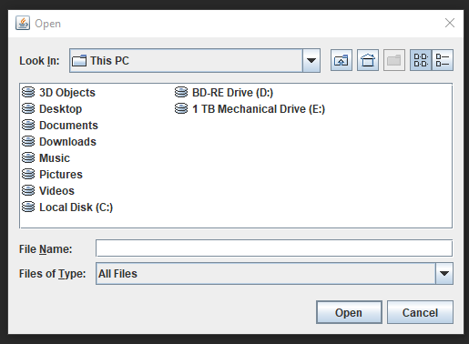

After selecting the appropriate scenario file, the simulation will begin and the scenario will start to unfold. If there is an error in your scenario file, then the software will alert you of this. Try running one of the three included factory scenarios to ensure everything is working correctly.